SOLUTION – CODING ACTIVITY 3.3

PART - 1

ManagedForm.jsx

import { useState } from "react";

export default *function* ManagedForm() {

*const* [name, setName] = useState('');

*function* updateName(){

        return(document.getElementById('print').innerHTML=`I live in ${name}`)

    }

    return (

      <>

           <h3>Managed Form</h3>

          <label>City: </label>

          <input type="text" id="cname" onChange={(*e*) *=>* setName(*e*.target.value)} />&nbsp;

          <input type="submit" value="Submit" onClick={updateName} />

        <p id="print"></p>

      </>

    );

  }

SAMPLE OUTPUT

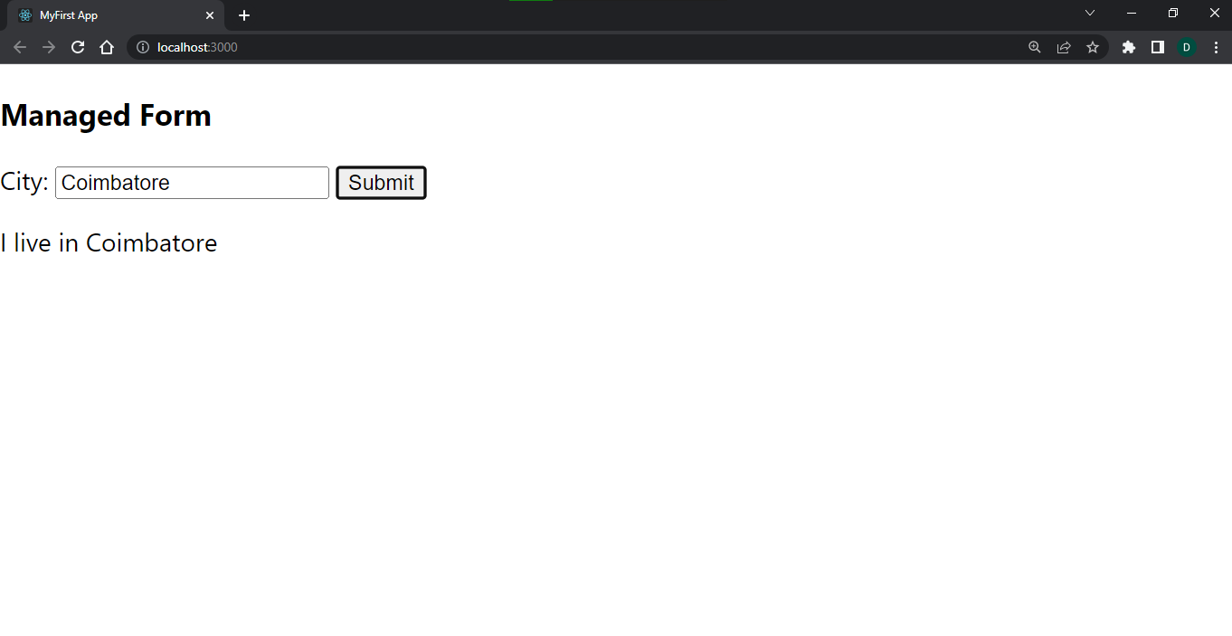

Figure 3.3.1

PART - 2

UnmanagedForm.jsx

export default *function* Unmanagedform(){

*function* submitForm(){

*let* cityname=document.getElementById('msg').value;

        return(document.getElementById('print').innerHTML=`I live in ${cityname}`)

    }

    return(<>

           <h3>Unmanaged Form</h3>

          <label>City: </label>

          <input type="text" id="msg" />&nbsp;

          <button onClick={submitForm}>click me</button>

        <p id="print"></p>

    </>)

  }

SAMPLE OUTPUT

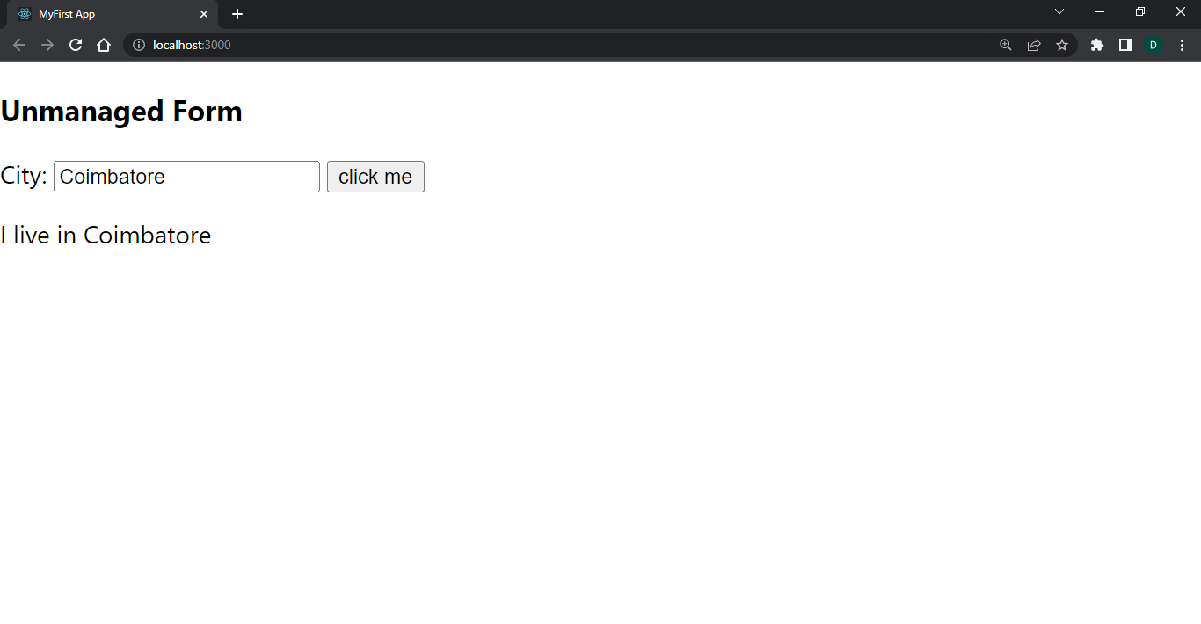

Figure 3.3.2